ALOPECIA: REGENERATIVE MEDICINE TO SAVE THE HAIR

Genetics, stress, lack of micro or macro nutrients… A slow, progressive, continuous hair loss is often considered a male problem, but in Europe one in 4 women suffers from it. The follicle weakens, the hair becomes finer, sparser, until it falls out. The change in the resulting physical aspect has a strong psychological impact and is a source of anxiety and discomfort in people's lives.
In particular for women, as hair has always been considered the symbol of femininity. And we talk about a high incidence: 70% of men and 40% of women suffer from androgenetic alopecia. But there is a remedy ...

THE EASY, SIMLE, EFFECTIVE REMEDY

The Seffihair® medical device is effective, safe, non-invasive. It is a combined protocol, where the most important component is REGENERATIVE MEDICINE, which is developing and spreading rapidly and is being adopted by the most advanced centers for its modern approach to the various problems including that of alopecia. As an alternative to hair transplantation, which we continue to do regularly, we frequently use this innovative technique, which exploits the naturalnreserves of our body, with an approach less invasive than surgery. The other strengths? Fast, safe, it guarantees good results and above all very fast recovery times: at the end of the session the patient can quickly return to everyday life.

WHAT HAPPENS DURING A SESSION?

It is almost more difficult to explain it than to perform it. To give you an idea, the SEFFIHAIR® medical device, designed by the Italian surgeon Alessandro Gennai, is based on a procedure that involves grafting the tissue taken from the same patient. This autologous graft, prepared with SEFFIHAIR®, stimulates hair growth, improves microcirculation and has an anti-inflammatory and antifibrotic action.
The session begins with a small harvesting of adipose tissue, usually taken from the abdomen or hips, where there is more fat. It is painless because it is carried out with a very thin cannula and a light local anesthesia is performed in the harvesting site.
In their study dott. Gennai, dott. Tesauro at al. proved that it’s possible to transfer stromal vascular fraction cells (SVF) from tissue to the liquid infranatant performing emulsification and centrifugation for 10 minutes (ref: Infranatant portion of microfragmented Adipose Tissue: a promising source of SVF for the management of Androgenic Alopecia Alessandro Gennai, Piero Tesauro, Mattia Colli, Silvia Zia, Barbara Roda and Andrea Zattoni, International Journal of Regenerative Medicine Volume 4(1): 2-7). The liquid component is taken from the vials after centrifugation, the famous autologous cell graft mentioned above, which is injected into the area affected by alopecia, with an extremely fine needle and therefore well tolerated by all patients.

THE STRENGTHS OF THE TECHNIQUE

The cells that belong to our body, once injected into the scalp, allow for hair growth and an improvement in microcirculation. The innovation of this technique lies in the fact that it is easily performed on an out-patient basis. Any aesthetic doctor can carry out the protocol of this device which is sterile, disposable and complete. Another advantage: any patient can undergo it, even if at an advanced age, unless there are particular pathologies.
It is very fast, because the whole session lasts no more than 40 minutes, including 10 minutes of centrifugation, and is completely painless. Recovery is very fast and the results, which begin to be visible after three months with a peak result of the single session around the sixth month, are really satisfying. Even a single session can give good results, but we tend to recommend three to four sessions over the course of a year. An effective, quick, safe and painless treatment that will allow everyone to have not only their hair back, but those very symbols of virility and seduction that, without bothering Samson and Berenice, have always revolved around the hair.

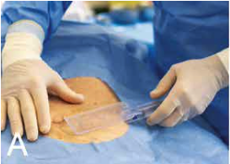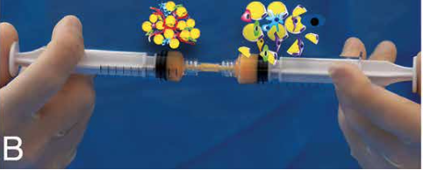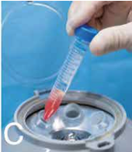
A = adipose tissue harvesting
B = Emulsification
C = Centrifugation

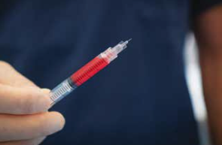
Tissue ready for injection

